

**Alpha Limit Company Trading and Contracting شركة الفا لميت لتجارة والمقاولات المحدودة-**

**Riyadh – Jeddah - Dammam**

**ABOUT US**

**Established by Dr.Saad Bin Ibrahim Bin Alageel , Alpha Limit Company is the distributor in the Middle East for electrical construction material & supplies. We offer a wide range of electrical, industrial, instrumentation and automation products from many of the world's leading manufacturers. Leveraging the global strength to build a competitive advantage to our customers.**

**Depending on our active *Sales* team and experienced *Technical support* team, we fully support our clients since the bidding stage and till the handover process. And continue to share the success with our clients in the after-sale services**

**At Alpha we continue to represent internationally well-known brands, many since the early days of our establishment. We have developed an ongoing program, which aims to expand our brand portfolio and products range, innovative and competitive solution.**

**Our range of industry solutions conform to both US (ANSI | NEMA | NEC) and European IEC specifications.**

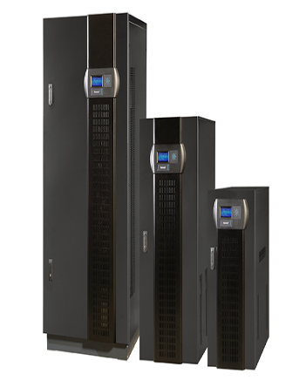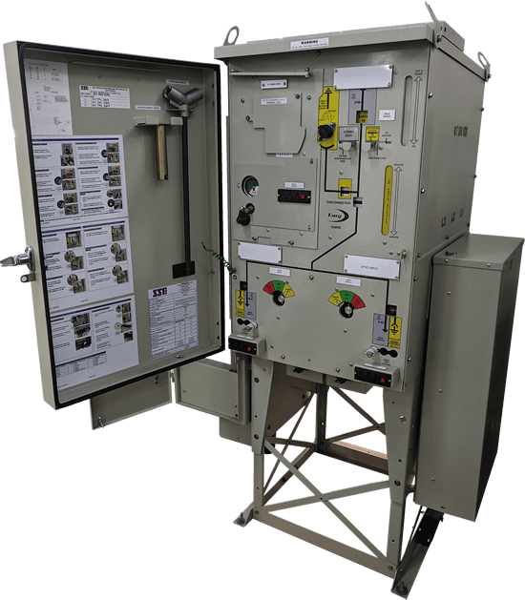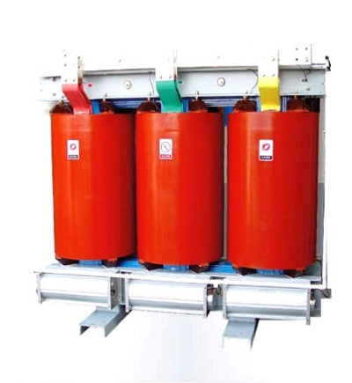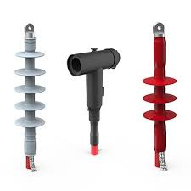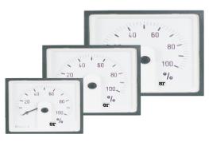

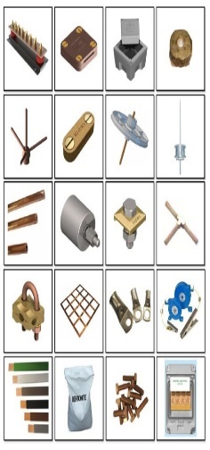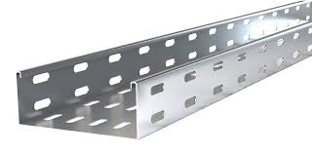

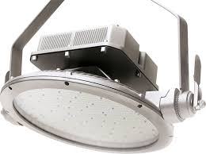

Index

Our mission

Being the preferred Choice of the Regional Supplier in our targeted markets, by building a strong relationship with our customers and suppliers. We create superior value for our stakeholders by working as a team to efficiently buy, sell and deliver our products to the Construction and Industrial markets.

Our vision

Be a league top player distribution company of Electrical, Industrial, Instrumentation, and Automation products & solutions, to the Construction and industrial markets in GCC.



**ALPHA Limit Partners**







 

 



**Uninterruptible Power Supply (UPS) & Batteries:**

* Line interactive Commercial UPS
* Industrial UPS
* Modular UPS
* Hybrid UPS
* SLA, VRLA batteries.
* Static transfer switches
* Static voltage regulators
* Automatic voltage regulators
* Frequency converters
* Inverters
* Solar products



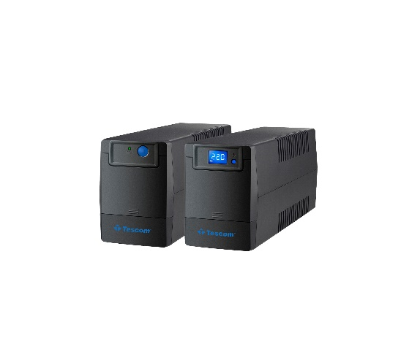

Line interactive

(1-2kVA)

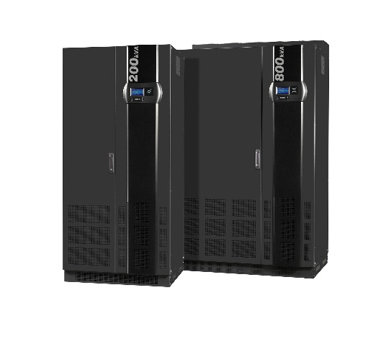

3 Phase In – 3 Phase Out

(10-3200kVA)

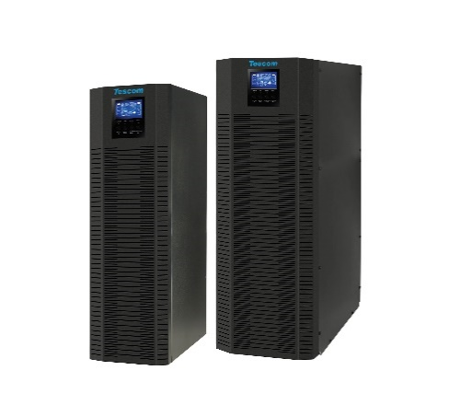

3 Phase In – 1 Phase Out

(10-40kVA)

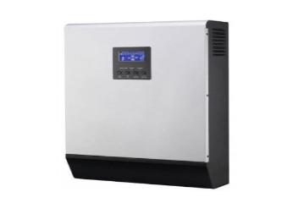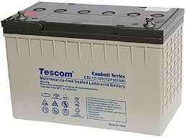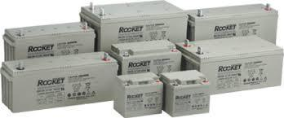

**Distribution Equipment & Power Protection**

* Ring Main Unit
* LV & MV Switchgear
* Automatic Transfer Switch
* LV Distribution Bords
* Relays & Contactors
* Unit & Package Substations
* Fuses
* Air Circuit Breakers
* Vacuum & SF6 Circuit Breakers
* Safety Switches
* Capacitor banks
* AC and DC panel



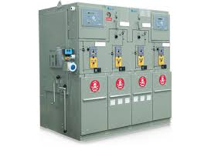

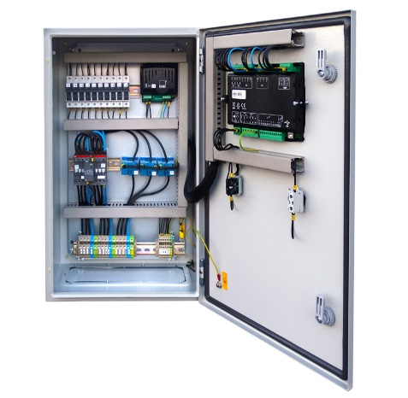

**Earthing & Lightening Protection**

* Conductors
* Earth Bars
* Earth Rods
* Earth Rod Seals
* Earth Rod Clamps
* Earthing Plates
* Mats
* Inspection Pits.
* Air Terminals
* Conductors
* Puddle Flanges
* Test Clamps
* Square Clamps
* DC Clips
* Early Streamer Emission devices.
* Surge Protection
* Exothermic Welding



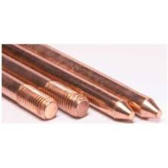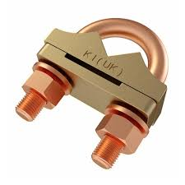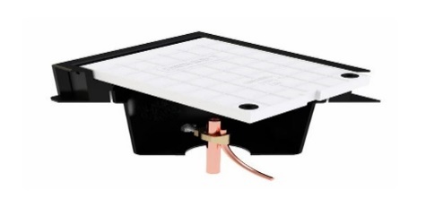

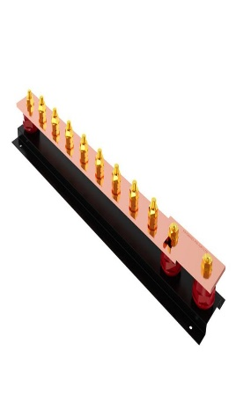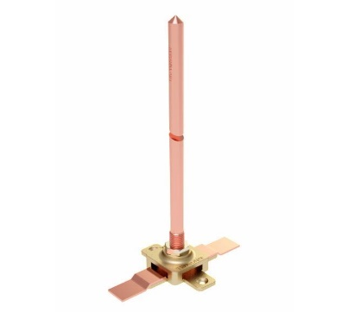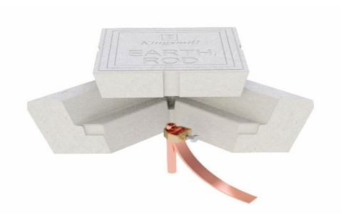

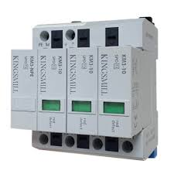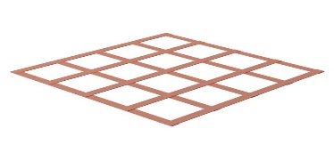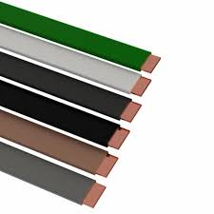

**Power Transformers**

* Dry type air transformer
* Dry type cast resin transformer
* Oil transformer
* Reactor
* Inductors
* Harmonic Mitigating Transformers



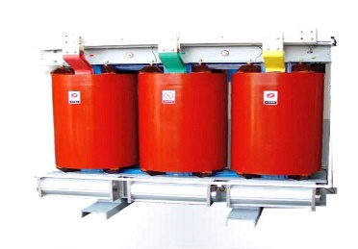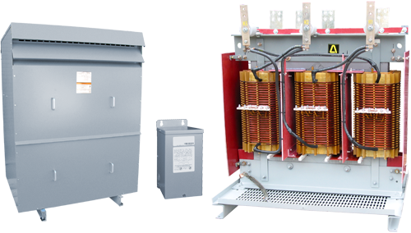

**Power Cable Accessories**

* Joints & Terminations
* Cable Lugs
* Cable Ties
* Cable Glands



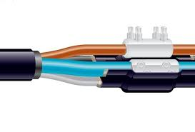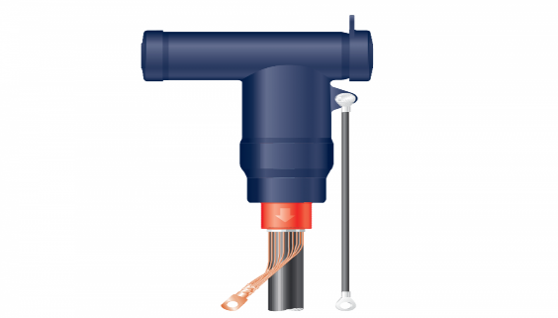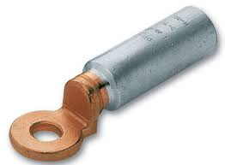

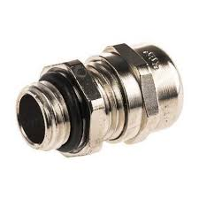

**Steel Products Cable Managmnet System & Towers**

* Cable Trays
* Cable Runway
* Undergrouend Ducts
* Raceways
* Cable Ties
* Electrical tower
* Communication tower
* Radar Tower

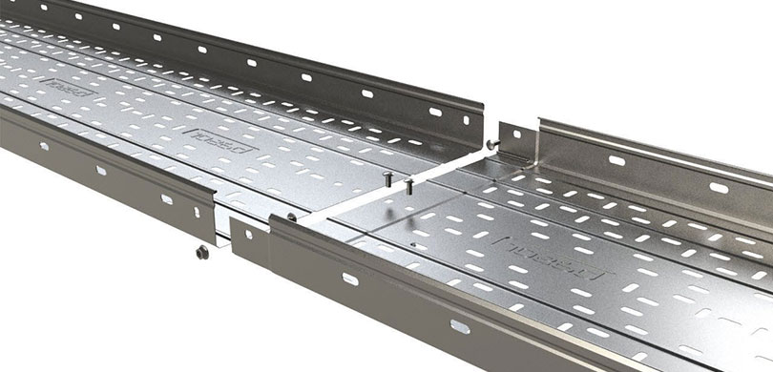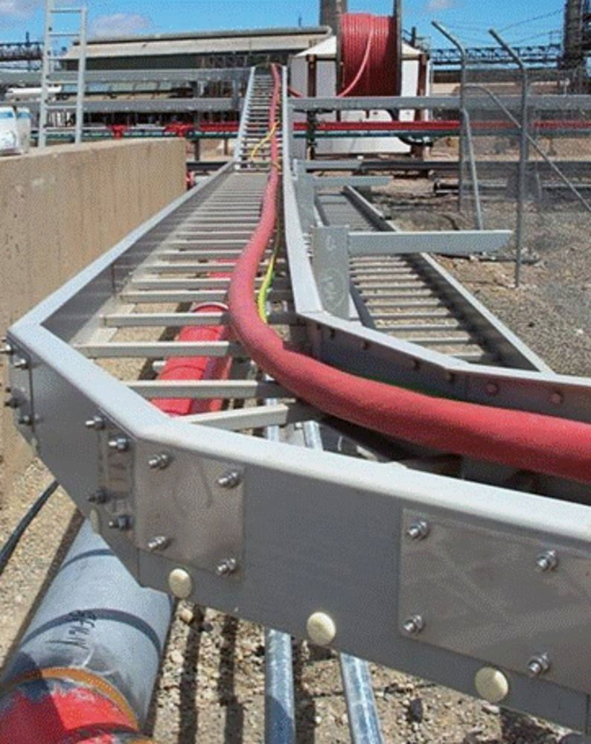

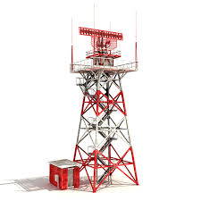

**Measuring Devices**

* Ammeters
* Voltmeters
* Multifunction meters
* Current transformers
* Analog panel meters
* kWh Energy meters
* Transducers and isolators
* Digital panel meters
* Converters and recorders
* Temperature controllers
* Digital mustimeters
* Protection relays

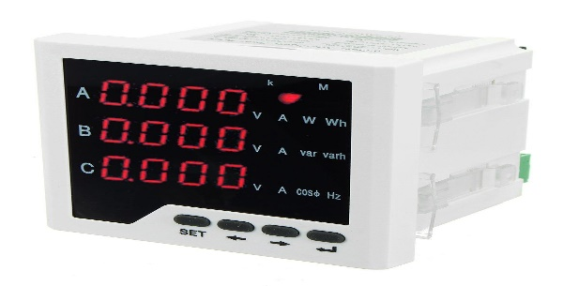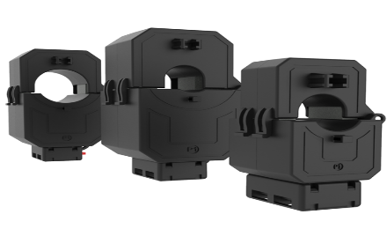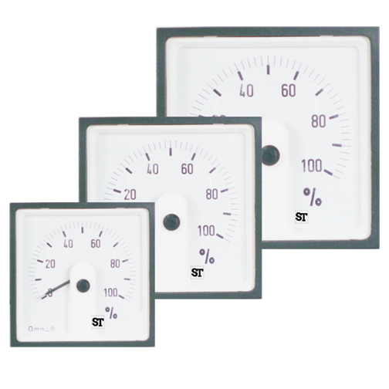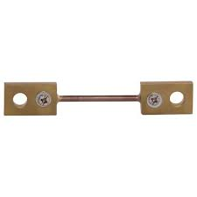

**Lighting Fixtures Buildings and factories**

* Outdoor and landscape lighting
* Solar lighting
* Street lighting
* LED Lighting fixtures
* Lamps
* Wall Switch
* Floor Switch
* Switches and sockets

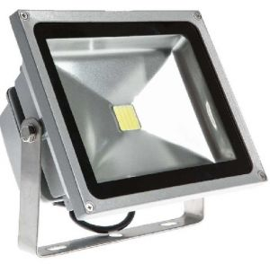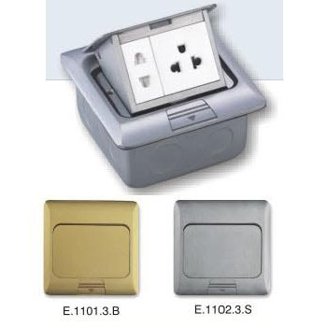

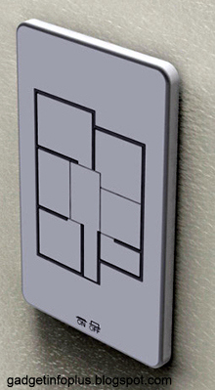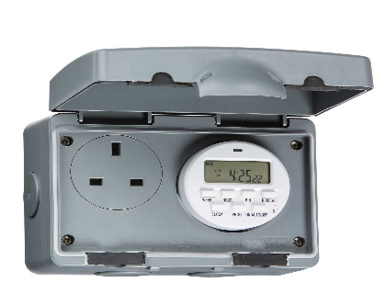

**Electrical installation**

* Cable joints, terminations and equipment installation
* Cable laying, installation, termination & splicing
* Electrical equipment installation.
* Heat, cold shrink or pre-mouled Elbows terminations
* Cabinet and Pole Top Terminations
* Lead Cable
* Splicing Dielectric to Lead
* Primary/secondary Voltage distribution
* Arc Proofing
* Secondary Networks: All voltages Transformers
* Pad or pole Mounted Transformers
* Electrical Testing